Wagyu AE – Opportunity Exploration

Ecosystem and Arena Identification
1. Ecosystem Definition
The ecosystem revolves around the premium protein value chain in the UAE, focused on meeting the demands of luxury dining and affluent lifestyles through exclusive, high-trust products.
- Key Players & Roles: As shown below, the ecosystem involves a global network of producers, logistics specialists, local distributors, and high-end consumers.
Player Category | Key Entities & Roles
Core Producers | Japanese Miyazakigyu, Omi Beef; Australian Fullblood Wagyu producers. Supply genetics, breeding expertise, and brand prestige.
Logistics & Infrastructure | Specialized cold-chain logistics, halal certification bodies, port authorities. Ensure integrity, compliance, and traceability.
Distributors & Intermediaries | Wagyu AE, Kobe Beef UAE, import/export specialists. Act as crucial gatekeepers, curators, and educators in the market.
End Consumers & Clients | Michelin-star/Gourmet restaurants, 5-star hotel F&B, UHNWI households, luxury caterers. Drive demand and set culinary trends.
Ecosystem Enablers | Food critics, culinary institutions, government trade bodies (e.g., JETRO). Shape market perception and facilitate trade.
- Major Interactions & Value Exchanges: The flow involves moving physical product (carcasses, cuts) and intangible value (brand story, certification trust, culinary expertise) from global farms to local plates. Critical exchanges include the transfer of halal and origin certifications and specialized knowledge on preparation between distributors and chefs.
- Systemic Outcomes: Participants collectively aim to deliver authentic luxury experiences, ensure supply chain integrity and traceability, and build culinary prestige and reputation for establishments.
2. Arena Identification
The broader ecosystem decomposes into three interconnected arenas, defined by the core "job-to-be-done" (JTBD) for customers.
Arena Name | Core JTBD | Key Interactions | Analysis for Wagyu AE
Luxury Protein Supply | "Source and deliver the highest-quality, certified raw ingredient reliably." | Transactional: Order fulfillment, logistics coordination, certification provision. | Your current core operation. High-value but linear; competition is on provenance and exclusivity.
Premium Halal Culinary Experience | "Create and deliver an unforgettable, culturally compliant gourmet dining event." | Knowledge-intensive: Chefs and distributors collaborate on menu design, cut selection, and cooking techniques. | High-opportunity space. Moves beyond logistics into co-creating value. Your exclusive Omi Beef is a key ingredient for this JTBD.
Connoisseur Identity & Access | "Access and possess rare, prestigious products that signify status and taste." | Curatorial & Community-based: Connecting connoisseurs with rare finds, stories, and like-minded communities. | Enables direct-to-consumer (DTC) and community models. Builds brand evangelists beyond B2B.
3. Scanning the Ecosystem for Platform Potential
- Long-tail markets: Fragmented on both ends. Many small, premium producers (e.g., boutique Australian ranchers) and niche consumers (private chefs, specialty grocers) lack efficient connection points.
- Aggregators: Currently limited. The market is served by a few linear distributors. There is no dominant digital platform aggregating supply, demand, and knowledge for premium halal meat specifically.
- Infrastructure providers: Enablers like digital halal traceability solutions and blockchain for provenance are emerging but not yet standardized.
Gap Analysis: A significant gap exists between the highly fragmented long-tail participants and the rigid, traditional supply chain. The "knowledge layer"—how to select, handle, and serve premium Wagyu—is also siloed and reliant on personal relationships, making it ripe for platformization.
4. Identifying Leverageable Assets and Moats
- Strategic Assets:
  - Relational: Your exclusive partnership with Omi Beef is a critical moat. Deep relationships with high-end chefs are also key.
  - Informational: Proprietary knowledge of the supply chain, halal certification processes, and chef needs.
  - Brand: Association with authenticity, exclusivity, and the Omi Beef legacy.
- Competitive Landscape: Direct competitors like Kobe Beef UAE operate on a similar linear model. The threat is from future digital aggregators or producers going direct via new platforms.
- Strategic Moats: The exclusive partnership is a strong defensive moat. A future platform could build network effects (more chefs attract more niche suppliers and vice versa) and a data advantage on premium meat preferences in the GCC.
5. Selecting an Arena for Focus
The "Premium Halal Culinary Experience" arena is recommended for your initial platform focus.
- Why This Arena?
  - Strategic Fit: It directly leverages your core asset (Omi Beef) and existing customer relationships (chefs). You are already part of this "job."
  - Market Opportunity: It addresses the critical knowledge fragmentation gap, creating stickier relationships than pure logistics.
  - Leverageable Assets: Your expertise and exclusive products can be the cornerstone of a trusted community and knowledge base.
Focusing here allows you to embed yourself deeper into the customer's value chain before a competitor does.

6. Mapping the Value Chain & Platform Strategy
This stage involves evolving from a linear pipeline (C-shape) to an interactive platform (Z-shape).
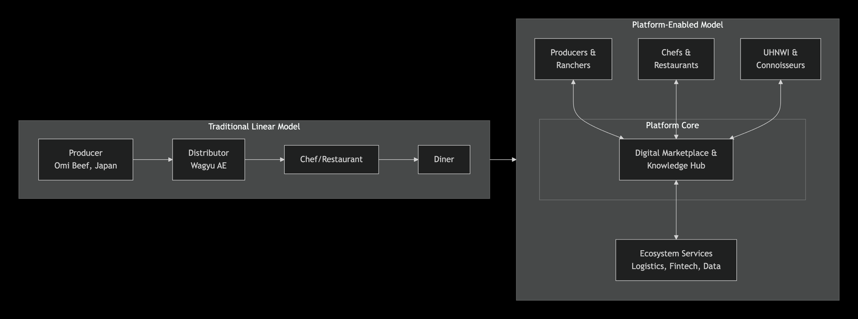

Applying the Six Platform Plays to transform this arena:
- Personalization: Offer chefs curated cuts based on their menu theme and past preferences.
- Empower Producers: Provide Omi Beef and other premium ranchers with direct market insights and brand storytelling tools.
- Standardize Transactions: Digitalize ordering, contracts, and halal certification documents.
- Embed Processes into SaaS: Offer a kitchen management tool for chefs to track inventory, costs, and pairing suggestions for premium meats.
- Leverage Trust & Reputation: Build a verified review and rating system for chefs and suppliers, anchored by your authority.
- Aggregate Demand & Supply: Create a marketplace connecting niche producers (e.g., specific Australian fullblood farms) with luxury hotels and private buyers.

7. Identifying Platformization Spaces
Within the "Premium Halal Culinary Experience" arena, three key subsystems can be platformized:
- The Knowledge & Collaboration Subsystem:
  - Opportunity: Capture and democratize the tacit knowledge of master chefs and butchers.
  - Platformization Action: Create a "Chef's Guild"—a subscription-based community with live butchery demos, recipe libraries, and Q&A sessions. This directly enables peer-to-peer learning and strengthens your brand's authority.
- The Procurement & Discovery Subsystem:
  - Opportunity: Move from manual ordering to dynamic discovery and sourcing.
  - Platformization Action: Develop a B2B marketplace that allows chefs to browse, compare, and bid on rare and specialty cuts from multiple certified suppliers (with Wagyu AE/Omi Beef as the anchor supplier). This aggregates fragmented supply and demand.
- The Experience & Storytelling Subsystem:
  - Opportunity: Extend the gourmet experience beyond the restaurant.
  - Platformization Action: Launch a DTC/Connoisseur platform for UHNWIs. Offer exclusive cuts, "chef-at-home" experiences booked through your network, and blockchain-enabled traceability stories showing the animal's origin and journey. This builds a powerful community and new revenue stream.
Next Steps and Strategic Implications
To initiate this platform transition, I recommend you begin with two concrete actions that leverage your existing strengths:
- Action 1: Validate the "Chef's Guild" Concept. Conduct structured interviews with your top 10 chef clients. Test their willingness to pay for a premium knowledge community and identify their most acute, unmet informational needs (e.g., specific cut utilization, halal pairing recipes).
- Action 2: Prototype a Digital Asset Pass. For your exclusive Omi Beef inventory, develop a simple digital "passport" (e.g., a web page/QR code) for each carcass. This should include the animal's lineage, harvest date, halal certification, and suggested preparation notes. Pilot this with 2-3 flagship restaurant clients to measure engagement and perceived value.
A successful pivot will fundamentally shift Wagyu AE's role from a distributor to the essential orchestrator of the UAE's premium halal meat ecosystem. This aligns perfectly with the Exponential Organisation (ExO) attributes of leveraging Communities, using Algorithms for matching, and building Engagement through digital tools

Arena - Premium Halal Culinary Experience
1. Arena & Systemic Job Definition
- Selected Arena: Premium Halal Culinary Experience
- Systemic Job: "Create and deliver an unforgettable, culturally compliant gourmet dining event."
- Key Interacting Entities:
  - Chefs (Producers of Experience): Translate raw ingredients into a branded dining event.
  - Distributors (Value-Added Suppliers): Provide core ingredients, certification, and expert knowledge.
  - Producers (Origin Story): Supply the certified raw ingredient and its narrative of authenticity.
  - Diners (Consumers of Experience): Seek status, exclusivity, and sensory pleasure.
- Key Pain Points & Inefficiencies:
  - Fragmented Knowledge: Critical expertise on cut selection, halal preparation, and pairing is siloed, residing in individual chefs or supplier reps, not shared systemically.
  - Opaque Discovery & Procurement: Chefs have limited visibility into rare or specialty cuts beyond their primary distributor. Procuring from multiple sources is manual and inefficient.
  - Disconnected Storytelling: The powerful narrative of origin (e.g., Omi Beef's 400-year lineage) and halal integrity is difficult to seamlessly transfer from farm to plate, diminishing perceived value.
2. Key Steps in the Current Process
The current linear process for accomplishing the systemic job can be broken down into key steps, categorized as either "Enabled" (currently functioning) or "Enabling" (areas ripe for platform intervention). The following flowchart maps this journey and its critical pain points.
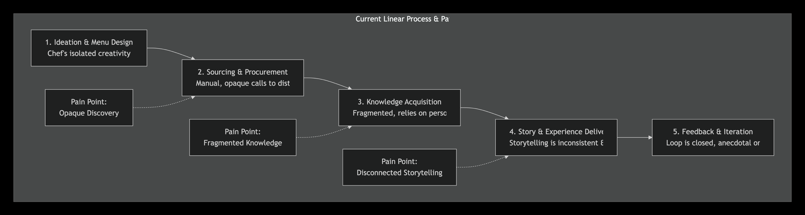

3. "Before" vs. "After" Platform Transformation
Step | BEFORE (Current State) | AFTER (Platform-Enabled State) | Nature of Change
1. Ideation & Design | Chef works in isolation, inspired by personal experience and limited supplier catalogs. | Chef accesses a digital inspiration hub: a community-driven library of successful dishes, plating ideas, and pairing suggestions from peers globally. | Aggregation & Community of creative knowledge.
2. Sourcing & Procurement | Manual process: calls/emails to known distributors, limited visibility into rare cuts, price negotiation is opaque. | B2B Marketplace: Real-time browsing of aggregated inventory from Wagyu AE and other vetted suppliers. Transparent bidding or fixed-price purchasing. | Digital Transaction Layer standardizing and aggregating supply.
3. Knowledge Acquisition | Relies on memory, a trusted supplier rep, or scattered online resources. No centralized authority. | Integrated Knowledge Base & Community: Step-by-step handling guides, live Q&A with master butchers, and peer forums are attached directly to the product listing and procurement platform. | Embedding Expertise into the transaction journey.
4. Story & Experience Delivery | The origin/halal story is verbally recounted by the server, often inaccurately or inconsistently. | Digital Storytelling Passport: A QR code on the menu links to a verified digital asset passport for that specific cut—showing lineage, farm, halal certification, and chef's notes. | Leveraging Data & Trust to enhance perceived value.
5. Feedback & Iteration | Feedback loop is closed; chef may adjust based on plate returns or verbal comments. Limited market intelligence. | Closed-Loop Data System: Diners can scan the QR to rate the experience. Anonymous, aggregated data on cut popularity and preparation success feeds back to chefs and producers, informing future demand. | Algorithmic Matching of supply with proven demand.
4. Defining the "Enabling" Components
To achieve the "After" state, specific platform enablers must be built or leveraged:
- Digital Trust & Verification Infrastructure:
  - Need: A system to immutably record halal certification and provenance data (e.g., blockchain or secure database).
  - Leveraged Asset: Wagyu AE's existing trust relationships with certification bodies and Omi Beef.
  - Output: API-accessible "Digital Product Passports."
- Aggregation & Matchmaking Algorithms:
  - Need: Software to aggregate supply listings and match them with chef demand based on cuisine type, price point, and cut characteristics.
  - Leveraged Asset: Deep knowledge of product attributes and customer preferences.
  - Output: Core B2B Marketplace engine with search, filter, and recommendation functions.
- Community & Knowledge Governance Framework:
  - Need: Rules and incentives for a professional community (e.g., contribution points, verification badges for master chefs).
  - Leveraged Asset: Reputation as the category authority and exclusive distributor.
  - Output: A thriving "Chef's Guild" platform where peer-to-peer learning is structured and valuable.
- Integrated SaaS Tools:
  - Need: Lightweight tools embedded in the procurement flow (e.g., yield calculator, cost-per-portion estimator, inventory tracker).
  - Leveraged Asset: Understanding of chefs' operational pain points.
  - Output: Sticky, value-adding features that lock in users to the platform.
5. Finalizing the Arena Scan
This arena is highly suitable for platformization:
- Significant, Recurring Job: Creating premium dining experiences is the core, repeatable activity for all high-end restaurants.
- High Fragmentation & Inefficiency: Knowledge, sourcing, and storytelling are currently fragmented, manual, and opaque, creating measurable friction and limiting scalability.
- Clear Scalability Opportunity: A platform can connect chefs not just to Wagyu AE, but to a wider ecosystem of niche suppliers, peers, and enabling services, increasing the value for all sides.
Conclusion and Strategic Path Forward:
The Arena Scan confirms that the "Premium Halal Culinary Experience" is fertile ground for transformation. Wagyu AE's strategic move is to evolve from a linear distributor to the orchestrator of a platform that aggregates supply, amplifies knowledge, and certifies trust. The immediate next step is to develop a minimum viable ecosystem (MVE) by building the first enabling component: the Digital Product Passport for Omi Beef. This tangible asset would validate the concept, deliver immediate value to existing clients through enhanced storytelling, and lay the foundational data infrastructure for future marketplace and community features.

Arena - Connoisseur Identity & Access
1. Arena & Systemic Job Definition
- Selected Arena: Connoisseur Identity & Access
- Systemic Job: "Access and possess rare, prestigious products that signify status and refined taste."
  - For Consumers (UHNWIs/Connoisseurs): To discover, authenticate, and acquire ultra-exclusive items that serve as social capital and personal gratification.
  - For Producers (Wagyu AE & Partners): To cultivate a prestigious brand halo, create direct, high-margin relationships with end-users, and build a community of brand evangelists.
- Key Interacting Entities:
  - The Connoisseur (Demand Side): UHNWIs, elite collectors, and gourmands who value provenance, rarity, and narrative over mere price.
  - The Curator (Supply Orchestrator): Wagyu AE, acting as the authentic gatekeeper, storyteller, and quality guarantor.
  - The Source (Supply Side): Exclusive producers like Omi Beef and other ultra-premium, niche suppliers that provide rarity.
  - The Validators (Ecosystem Enablers): Sommeliers, private chefs, luxury concierges, and peer networks that influence and validate purchasing decisions.
- Major Pain Points & Inefficiencies:
  - Opaque Discovery & Access: Truly rare products (e.g., specific Omi Beef bloodlines, limited harvests) are invisible to the market. Access is gated by personal introductions or chance, not merit or passion.
  - Fragmented Trust & Provenance: Authenticity and the "story" are hard to verify and communicate. The value narrative from farm to final cut is often lost.
  - Transactional, Not Relational: Current DTC models (e.g., e-commerce with fast delivery ) focus on convenience, not curation or community. They fail to build the sustained relationships that drive lifetime value and advocacy in this segment.
2. Key Steps in the Current ("Before") Process
The current process for fulfilling the connoisseur's systemic job is largely linear, opaque, and fragmented. The following table breaks down this journey and its associated pain points.
Step | Key Actions & Interactions | Value Flow | Category & Pain Points
1. Desire & Search | Connoisseur desires a "peak experience" item. Searches through personal networks, chefs, or generic premium websites . | Information flows through weak, informal ties. | Fragmented. High search cost. Relies on luck and existing network strength.
2. Discovery & Verification | If a source like Wagyu AE is found, verification is manual: emails/calls to confirm availability, authenticity (Halal, Omi provenance), and details. | Trust is built slowly through 1:1 dialogue. Supplier provides proof. | Manual & Inefficient. Slow, scales poorly, and lacks immutable proof (e.g., digital certificates).
3. Procurement & Fulfillment | Order is placed manually. Logistics are arranged as a standard shipment, albeit with premium packaging. | Money for goods and delivery. Physical product moves. | Enabled, but Generic. The experience is functionally identical to any premium delivery , missing a tailored "unboxing" ritual.
4. Possession & Storytelling | Connoisseur receives the product. The ability to share its full story—lineage, harvest date, artisan—is limited to a verbal retelling. | Social capital is generated but its amplification is constrained. | Broken Story Loop. The most valuable asset (the provenance data and narrative) is not systematically captured or transferable, limiting shared value.
5. Re-engagement | Supplier may follow up via email. Next purchase depends on memory or a new marketing campaign. | Potential for recurring value is untapped. | Non-Systemic. No structured path for deepening the relationship, learning preferences, or offering tiered access.
3. Comparing "Before" and "After" Platform Transformation
The platform strategy aims to transform this arena from a closed, transactional model into an open, community-centric ecosystem .
Aspect | BEFORE (Linear & Closed) | AFTER (Platform & Community-Centric)
Core Model | One-to-many distribution. Wagyu AE as a Seller. | Multi-sided curation. Wagyu AE as the Orchestrator of a trusted network.
Discovery | Opaque, based on private inventory. | Dynamic marketplace/auction for "hero lots" (e.g., entire carcass of a prized animal), visible only to vetted members.
Trust & Verification | Manual assurance, paper certificates. | Digital Product Passports (NFT or blockchain-linked) containing immutable data on lineage, Halal certification, photos, and chef tasting notes .
Value Exchange | Money for meat. | Multi-layered: Money for exclusive goods + Reputation Data (reviews, curation) + Community Contribution (knowledge sharing).
Relationship | Transactional, episodic. | Relational, continuous. Tiered membership (e.g., Apprentice, Connoisseur, Collector) with escalating access, events (virtual farm tours, masterclasses with chefs), and co-creation opportunities.
Storytelling | Static, one-way narrative. | Living story attached to the digital passport, which can be added to by each owner (e.g., "Served at my daughter's wedding"), increasing its cultural and monetary value.
4. Defining the "Enabling" Components
Building the "After" state requires specific foundational components:
- Digital Trust & Asset Infrastructure:
  - Need: A system to create, manage, and trade Digital Product Passports. This acts as the core "trust layer."
  - Leveraged Asset: Wagyu AE's exclusive contracts and deep producer relationships (Omi Beef) to anchor initial supply with undeniable authenticity.
  - Output: A simple blockchain registry or secure database that issues a unique, verifiable digital identity for each premium product unit.
- Gated Community & Governance Framework:
  - Need: Rules for membership, contribution, and value distribution. How are members vetted? How are top contributors rewarded?
  - Leveraged Asset: Existing B2B client list (luxury hotels, top chefs) as founding community members and validators.
  - Output: A clear membership model and a reputation system that grants status (e.g., "Verified Taster," "Master Curator").
- Curation & Matchmaking Logic:
  - Need: Algorithms and human curation to match rare supply with member profiles and preferences.
  - Leveraged Asset: Proprietary knowledge of product attributes and client tastes.
  - Output: A discovery engine that personalizes listings and alerts for members, and a curation panel of experts (including community-elected connoisseurs).

5. Finalizing the Arena Scan: Platformization Potential
This arena is highly suitable for platformization based on the PDT validation criteria:
- Significant & Recurring Job: The drive for status, exclusivity, and unique experiences is a profound and recurring motivator for UHNWIs.
- High Friction & Fragmentation: Discovery is opaque, trust is cumbersome to establish, and the post-purchase story loop is broken. These are classic indicators of high "transaction cost."
- Scalable Connection Opportunity: A platform can efficiently connect a global, long-tail supply of niche luxury producers (not just Omi, but also rare Italian Fassona, specific Iberian breeds) with a global, fragmented demand of connoisseurs, scaling far beyond Wagyu AE's current manual reach.
Strategic Recommendations & Next Steps
- Immediate Validation (30-60 Days): Do not build software first. Instead, manually prototype the platform experience.
  - Action: Select 5 top UHNWI clients. For their next order of Omi Beef, create a simple, beautiful "digital provenance page" (PDF/private webpage) with the animal's story, certificates, and chef pairing suggestions. Interview them extensively on the perceived value of this asset.
- Phase 1: Build the Trust Core (MVP in 3-4 Months):
  - Develop the Minimum Viable Ecosystem (MVE): A simple, members-only web portal. Its sole functions: 1) Showcase 3-5 "ultra-premium lots" with their Digital Passports, and 2) Enable a request-to-buy (not open cart) function.
  - Onboard Foundational Members: Invite 20-30 top chefs and known connoisseurs from your network as founding members.
This approach allows you to validate the core value hypothesis—that verifiable provenance and exclusive access are worth a significant premium—with minimal risk, laying the groundwork for a defensible, scalable platform that transforms Wagyu AE from a distributor into the central node in a global network of luxury food connoisseurs.

Arena - Luxury Protein Platform
1. Arena & Systemic Job Definition
- Selected Arena: Luxury Protein Supply
- Systemic Job: "Source and deliver the highest-quality, certified raw ingredient reliably and efficiently for high-end culinary businesses." This job is not just about moving a box from A to B; it is about guaranteeing integrity (halal, breed purity), consistency (of marbling, grade), and critical information flow (certification, cut specifications) alongside the physical product.
- Key Interacting Entities:
  - Producers & Exporters: Exclusive sources like Omi Beef and other premium Wagyu farms in Japan and Australia. They provide the core product and its authentication.
  - The Distributor (Wagyu AE): The central node responsible for import, logistics, certification validation, inventory management, and B2B sales.
  - B2B Clients: High-end restaurants, hotels, and caterers who require guaranteed quality, specific cuts, and reliable delivery schedules.
  - Logistics & Certification Enablers: Specialized cold-chain freight forwarders, halal certification bodies, and customs brokers.
- Major Pain Points & Inefficiencies:
  - Informational Friction & Opaqueness: Ordering is manual (phone/email). Clients have poor visibility into real-time inventory of specific cuts, leading to back-and-forth communication. Traceability data from farm to plate is fragmented.
  - Inefficient Matching & Planning: The distributor's sales team manually matches available inventory (often entire carcasses) to client needs. This leads to suboptimal carcass utilization and difficulty forecasting demand for specific cuts.
  - High Transaction Costs: Each order involves significant manual coordination for quoting, order confirmation, certification provision, and logistics coordination. This limits scalability.
2. Key Steps in the Current ("Before") Process
The current process is a linear, push-based supply chain with high manual overhead.
Step | Key Actions & Interactions | Value Flow | Category & Pain Points
1. Inventory Acquisition & Planning | Wagyu AE places bulk orders from Omi Beef based on forecasts. Carcasses are shipped, cleared, and stored. | Physical goods move; capital is tied in inventory. | Enabled, but Rigid. High forecasting risk. Capital intensive. Matching supply to latent demand is guesswork.
2. Client Inquiry & Quotation | Chef calls/emails requesting specific cuts (e.g., 20kg of A5 Striploin). Sales rep checks physical/ spreadsheet inventory, provides a manual quote. | Information request; price offer. | Manual & Repetitive. High time cost per quote. Inventory data may be outdated, causing errors.
3. Order Matching & Carcass Breakdown | Upon confirmation, operations team assigns the cut from a specific carcass, aiming to utilize the rest efficiently. | Commitment to supply; internal planning trigger. | Fragmented & Inefficient. Optimal matching is complex and done ad-hoc. Leads to waste of less popular cuts.
4. Documentation & Certification | Manual compilation of halal certificates, health certificates, and customs documents for each order or batch. | Trust & compliance documents. | Manual & Redundant. The same core certificates are repeatedly processed and shared.
5. Logistics & Fulfillment | Coordination of last-mile cold-chain delivery, often merging multiple client orders on a route. | Physical delivery of goods. | Enabled, but Unoptimized. Route and load planning is manual, missing opportunities for consolidation.
6. After-Sales & Reordering | Invoicing is manual. Reordering relies on the chef remembering or the sales rep calling. | Payment; trigger for next cycle. | Reactive, not Predictive. No systematic data capture to anticipate client needs.

3. Comparing "Before" and "After" Platform Transformation
A platform transforms this arena from a linear, opaque pipeline into a digital, multi-sided network that optimizes the entire system.
Aspect | BEFORE (Linear Supply Chain) | AFTER (Intelligent Supply Network)
Core Model | Push-based: Forecast, buy, store, then sell. | Pull-based: Aggregate real-time demand, then optimize procurement and allocation.
Inventory Visibility | Private spreadsheet or ERP, shared manually. | Public Digital Inventory: A real-time, shared view of available cuts and carcasses for vetted B2B clients.
Ordering & Matching | 1:1 manual sales process. | Algorithmic Matching & Bidding: Chefs can see available lots. The platform can suggest optimal carcass breakdowns across multiple orders to maximize yield and value.
Documentation & Trust | Static PDFs emailed per request. | Embedded Digital Certificates: Each SKU in the system has a link to immutable halal/origin certificates, accessible to the end-client's kitchen.
Value Creation | Margin on product markup. | Multi-layered Value: 1) Transaction Fee on marketplace sales. 2) SaaS Fee for access to planning/ procurement tools. 3) Data Insights sold back to producers on cut popularity.
Role of Wagyu AE | Asset Owner & Seller. Holds all inventory risk and manages all ops. | Network Orchestrator & Service Provider. Manages the platform, can also sell own inventory, and offers logistics/fulfillment as a service to other importers.
4. Defining the "Enabling" Components
To build the "After" state, the following digital and governance infrastructure is required:
- Digital Product Catalog & Trust Layer:
  - Need: An API-accessible database where each physical cut (or carcass) is a digital twin, linked to its certificates, photos, and test results.
  - Leveraged Asset: Wagyu AE's exclusive Omi Beef inventory as the initial, high-trust supply to anchor the platform.
  - Output: The core "source of truth" for all transactions.
- Demand Aggregation & Matching Engine:
  - Need: Algorithms that allow clients to express demand (e.g., "need 50kg of A4+ ribeye in 2 weeks") and intelligently match it to available supply (full carcasses, sub-primals), optimizing for yield, freshness, and cost.
  - Leveraged Asset: Deep operational knowledge of butchery yields, client preferences, and logistics.
  - Output: Automated order bundling and carcass utilization plans that reduce waste and increase margin.
- Standardized Integration Protocols:
  - Need: APIs or simple data standards to connect with restaurant procurement systems (like ChefTec or MarketMan), logistics providers, and certification bodies.
  - Leveraged Asset: Existing relationships with clients and logistics partners as pilot integrators.
  - Output: Seamless data flow, eliminating manual re-entry of orders and tracking numbers.
5. Finalizing the Arena Scan: Platformization Potential
This arena is exceptionally suitable for platformization:
- Significant & Recurring Job: Sourcing premium protein is a core, daily/weekly operational job for every high-end restaurant. The stakes (cost, quality, consistency) are extremely high.
- High Fragmentation & Inefficiency: The current process is riddled with manual, repetitive steps (quoting, order entry, certificate sharing), opaque inventory, and suboptimal physical matching.
- Scalable Connection Opportunity: A platform can connect multiple premium suppliers (not just Omi) to a concentrated pool of high-volume B2B buyers. It can scale by adding new product categories (e.g., premium lamb, exclusive seafood) and new geographies within the GCC.
Strategic Recommendations & Next Steps
- Immediate Action - Digitize the Core Asset: Before building a multi-sided platform, create the digital foundation.
  - Action: Implement a simple system to give each incoming Omi Beef carcass a QR code/digital profile. Scan it at each stage (arrival, breakdown). This creates a traceable digital twin and is the first step toward the Digital Trust Layer.
- Phase 1: Build a "Transparent Supplier Portal" (MVP in 2-3 Months):
  - Goal: Solve the biggest pain point for your existing top 20 clients: inventory visibility and ordering.
  - MVP Features: A private, client-login website showing real-time available inventory (cuts, weights, grades) with embedded certificates. Enable direct online ordering from this list.
  - Outcome: This eliminates 80% of manual quote requests, streamlines ordering, and provides your first digital demand data.
This approach de-risks the platform journey. You start by making your current linear business exponentially more efficient and data-rich. This digital backbone then becomes the springboard to open the network to other suppliers and buyers, fundamentally evolving Wagyu AE from a distributor to the operating system for luxury protein supply in the region.

Wagyu Ecosystem
1. Defining the Broad Ecosystem
- Ecosystem Context: You operate within the Premium Halal Protein Supply Chain for luxury dining and affluent lifestyles in the UAE. This ecosystem is defined by extreme requirements for quality (authentic Wagyu), trust (halal certification, provenance), and exclusivity.
- Major Participants & Roles:
Participant Category | Key Entities & Roles | Core Systemic Jobs
Producers (Value Creators) | Omi Beef (your exclusive partner), other Japanese/Australian Wagyu ranches, specialty halal protein producers. | Supply authentic, high-grade products with guaranteed provenance and certifications.
Consumers (Value Receivers) | B2B: Michelin-star restaurants, 5-star hotel F&B, luxury caterers. B2C: Ultra-High-Net-Worth Individuals (UHNWIs). | Acquire prestigious ingredients to create exceptional culinary experiences and signify status.
Aggregators (Interaction Facilitators) | Wagyu AE (current role: exclusive distributor), other niche meat importers, luxury gourmet stores. | Curate supply, guarantee authenticity, and bridge the geographic/logistical gap between global producers and local elites.
Infrastructure Providers (Operational Support) | Halal certification bodies, specialized cold-chain logistics, customs brokers, trade finance, premium packaging. | Provide critical trust signals, physical flow enablement, and compliance.
2. Mapping Value Exchanges & Identifying Fragmentation
The current ecosystem is linear and relationship-driven, with significant fragmentation on both the supply and demand sides.
- Key Value Exchanges: The primary flow is physical goods (carcasses, cuts) + intangible trust (certificates, brand story) moving from producers to end-users, with money flowing back. Critical supporting exchanges include logistics services and regulatory compliance.
- Bottlenecks & Inefficiencies:
  - Fragmented Supply Discovery: High-end chefs and UHNWIs have no efficient way to discover or compare rare products (e.g., specific Wagyu bloodlines, heritage breeds) beyond their known distributors.
  - Opaque Trust Verification: Halal and provenance claims are verified through static paper certificates, creating manual overhead and limiting transparent storytelling to the end consumer.
  - Inefficient Matching: Distributors like Wagyu AE manually match whole carcasses to client demand, leading to suboptimal yield and difficulty moving less popular cuts.
- Concentration vs. Fragmentation: The ecosystem is polarized. It is concentrated around a few key distributors and logistics providers who control market access. However, both the supply side (small, premium ranches globally) and the demand side (numerous high-end chefs, private buyers) are highly fragmented, creating a classic "many-to-many" disconnect.
3. Analyzing the Three-Layered Market Structure
Layer | Description & Examples in Wagyu AE's Ecosystem
Long-Tail (Fragmented) | Supply: Numerous small-scale, premium Wagyu and specialty protein producers outside major brands. Demand: Individual private chefs, boutique hotels, affluent households, and niche caterers. Characterized by high-value, low-volume, personalized needs.
Aggregators (Concentrated) | Current Aggregators: Wagyu AE and a handful of other importers act as linear aggregators, but in a closed, non-scalable way. Gap: No digital multi-sided platform exists to dynamically aggregate the long-tail supply and demand for premium halal meat.
Infrastructure (Componentized) | Physical: Specialized cold-chain logistics, halal abattoirs. Digital & Trust: Emerging but underutilized. This includes blockchain for traceability, digital halal certification APIs, and B2B procurement software. This layer is not yet fully componentized for easy integration.
4. Identifying Key Market Dynamics & Platform Opportunity
The core dynamic is a fragmented long-tail being inefficiently served by linear aggregators, creating high transaction costs and unmet demand.
- Scaling Challenge: Your current exclusive distributor model scales linearly with sales effort and capital tied in inventory. It cannot easily scale to connect the vast global long-tail of premium producers with the UAE's concentrated luxury demand.
- Primary Opportunity: The biggest inefficiency is the lack of a trusted, centralized discovery, verification, and transaction layer. This represents a clear gap for a platform that can reduce search costs, automate trust, and optimize matching.
- Network Effects Potential: A platform that attracts high-end chefs becomes valuable to niche producers, and vice-versa. A data network effect is also possible: aggregated data on cut popularity and preparation can guide producers and chefs, creating a self-improving ecosystem.

5. Spotting Potential for Platformization
The scan reveals a strong opportunity for Wagyu AE to leverage its exclusive assets and market authority to build a platform. The goal is to evolve from a pipe to a platform, as visualized below.
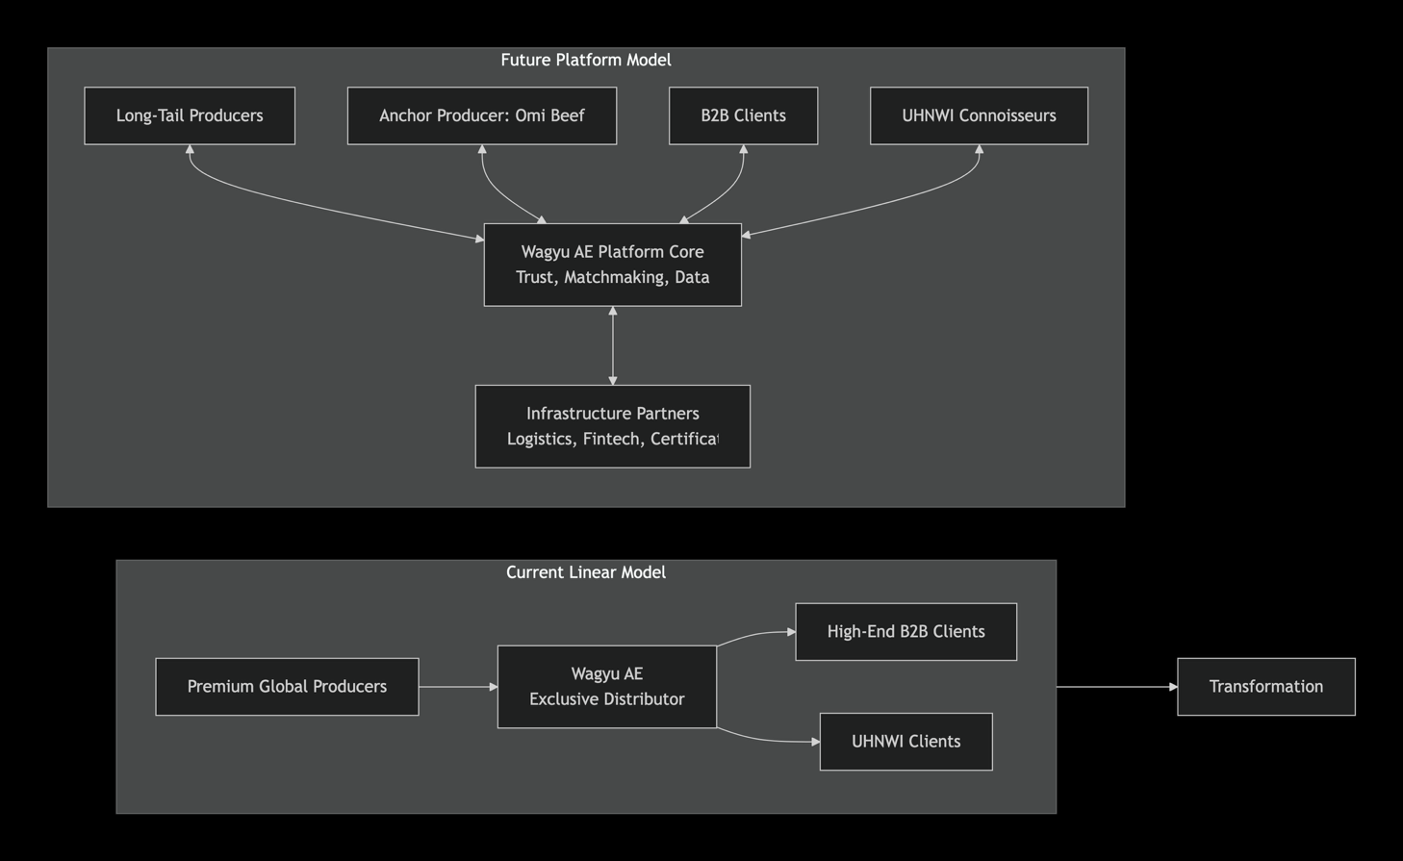

Specific Platformization Spaces:
- Trust & Provenance as a Service: Develop a digital halal provenance platform. Use QR codes/blockchain to give each cut a verifiable digital passport (lineage, certs, journey). This can be your platform's core trust layer, initially applied to Omi Beef, then offered as a white-label service to other premium producers.
- B2B Marketplace for Rare Cuts: Create a members-only marketplace. You remain the anchor supplier with Omi Beef, but also onboard other vetted niche producers. Chefs gain discovery; producers gain access; you gain a transaction fee and invaluable demand data.
- Demand Aggregation & Yield Optimization SaaS: Build tools that allow chefs to pre-order specific cuts. Your platform's algorithm then aggregates this demand to optimize the breakdown of whole carcasses across multiple buyers, reducing waste and increasing margins for everyone.
- Connoisseur Access & Community: Develop a gated DTC channel for UHNWIs. Offer exclusive cuts, "chef-table" experiences with your partner restaurants, and subscription boxes. This builds a high-margin community and turns clients into brand evangelists.

Strategic Path Forward
Your Exclusive Omi Beef partnership and deep B2B relationships are your critical moats and launching pads. The recommended path is to first build the digital trust layer for your core business.
- Phase 1 (Core Digitization): Create Digital Product Passports for your Omi Beef inventory. This solves an immediate client pain point (storytelling, verification) and builds your key platform asset: structured, verifiable product data.
- Phase 2 (Controlled Marketplace): Launch a private marketplace for your top 20-30 restaurant clients, offering them this digitized Omi Beef alongside 2-3 other carefully curated premium products. Test transaction and subscription fees.
- Phase 3 (Open Platform): Based on learnings, open the platform to more suppliers and buyers, and develop the SaaS and community layers.
This progression allows you to validate the platform model with minimal risk, leveraging your existing strengths to become the indispensable ecosystem orchestrator for premium halal protein in the region.

VRIO Analysis
1. Key Resources & Capabilities for Platformization
Your most critical assets are predominantly intangible and relational, which are ideal foundations for a platform.
Category | Resource / Capability | Description & Platform Relevance
Intangible Resources | 1. Exclusive Partnership with Omi Beef | Sole UAE distributorship of a legendary, 400-year-old brand. This is the ultimate trust anchor and category authority signal for a platform.
 | 2. Deep B2B Relationships | Trusted relationships with chefs and procurement heads at high-end venues. This provides a ready-made, high-value initial network for a B2B platform.
 | 3. Halal Certification Expertise & Trust | Deep operational knowledge and verified processes for halal compliance. This can be productized as a trust and verification service on a platform.
Capabilities | 4. Premium Product Curation & Storytelling | Ability to select supreme quality and articulate its provenance/narrative. This is the core of curation algorithms and community education in a platform.
 | 5. Specialized Cold-Chain Logistics Management | Expertise in handling and delivering ultra-premium perishables. This can be standardized and offered as a fulfillment-as-a-service layer for the platform.
 | 6. High-Touch, Consultative Sales | Understanding client needs and providing tailored solutions. This insight is the seed data for personalization and matchmaking in a digital platform.

2. VRIO Framework Analysis
The following table applies the VRIO framework to determine which resources can deliver a sustained competitive advantage in a platform context.
Resource/Capability | Valuable? | Rare? | Inimitable? | Organized? | VRIO Score & Strategic Position
1. Exclusive Omi Beef Partnership | Yes. It defines the luxury category, allows premium pricing, and is the core value proposition. | Yes. By definition, an exclusive contract is rare and controlled by one entity. | Yes. Legally protected by contract. Reputation and history of Omi Beef cannot be replicated. | Yes. Current business model is fully built around exploiting this. | V, R, I, O → Sustained Competitive Advantage. Your strongest moat.
2. Deep B2B Relationships | Yes. Reduces customer acquisition cost and provides reliable demand. Critical for launching a platform. | Yes. Trust at this level in the luxury segment is built over years and is not common. | Partly. Relationships can be poached, but the collective network is hard to copy wholesale. | Partly. Leveraged for linear sales, but not yet organized as a network asset for a platform. | V, R, I → Temporary Advantage. Must be organized into a platform community to sustain.
3. Halal Certification Expertise | Yes. Non-negotiable for the market; a key trust component. | No. Many entities possess halal certification knowledge. | No. Processes can be learned and certified by others. | Yes. Deeply integrated into operations. | V, O → Competitive Parity/Necessity. It is a cost of entry. Its value is in how it's digitally leveraged.
4. Premium Curation & Storytelling | Yes. This is the service that turns a product into an experience, justifying high margins. | Yes. True expertise in Wagyu grading and narrative is scarce. | Yes. Based on tacit knowledge, experience, and taste – difficult to codify and copy quickly. | Partly. Used in sales, but not systematized as a scalable digital asset (e.g., a content library or algorithm). | V, R, I → Temporary Advantage. Must be productized (e.g., into a SaaS tool or certification) to become organized.
5. Specialized Logistics Mgmt. | Yes. Ensures product integrity, the most basic requirement. | No. Many third-party logistics providers offer cold chains. | No. Can be outsourced or developed with capital investment. | Yes. Well-executed in current model. | V, O → Competitive Parity. An efficiency. Platform opportunity lies in orchestrating this infrastructure as a service.
6. High-Touch Consultative Sales | Yes. Uncovers latent needs and drives customer satisfaction. | No. Many B2B sales organizations have this capability. | Partly. The specific knowledge of client preferences is unique data, but the sales model is replicable. | Partly. Tied to individual staff. Not yet organized as a centralized data asset. | V → Competitive Parity. The data generated by this capability is the rare asset, not the activity itself.

3. Strategic Implications & Platformization Opportunities
Your Sustained Advantage (Omi partnership) is the perfect anchor, while your Temporary Advantages (Relationships, Curation) are the key platformization levers.
Resource/Capability | Platformization Opportunity & Strategic Action
Exclusive Omi Partnership (Sustained Advantage) | Action: Leverage as the Trust Anchor. Use Omi Beef as the flagship, trust-verifying brand to launch a broader marketplace. Concept: "From the Curators of Omi Beef" – a platform featuring other vetted, ultra-premium producers. This turns a exclusive product into an exclusive curation seal.
Deep B2B Relationships (Temporary Advantage) | Action: Organize into a Networked Community. Launch an invitation-only "Chef's Guild" or "Buyers' Club" on the platform. Offer early access to rare lots, masterclass content, and peer networking. This formalizes relationships into a digital network with high switching costs.
Halal Certification Expertise (Parity) | Action: Productize into a Trust Layer. Develop a digital halal provenance and traceability system (e.g., blockchain-lite). First, apply it to Omi Beef to enhance its story. Then, offer it as a verification service to other producers on your platform, creating a new revenue stream and a scalable trust standard.
Curation & Storytelling (Temporary Advantage) | Action: Embed into Algorithmic Curation & SaaS. Codify your curation logic into platform filters, recommendations, and "Curator's Picks." Package storytelling tools (digital producer profiles, cut-by-cut guides) as value-added services for producers, helping them sell better.
Consultative Sales Data (Parity) | Action: Aggregate into a Demand Intelligence Engine. Systematically capture purchase and preference data from interactions. Use this to build predictive analytics for producers (e.g., "Ribeye demand rising in Dubai 5-stars") and personalized procurement forecasts for chefs, creating immense platform stickiness.

4. Final Strategic Roadmap
Your path to platform leadership involves exploiting your sustained advantage to launch, and transforming temporary advantages into organized, systemic ones.
- Immediate Priority (0-6 Months): Protect & Leverage the Core
  - Initiative: Launch the "Omi Beef Digital Provenance" Experience. Build the digital trust layer for your core asset. This validates the platform concept, delights existing clients, and creates your first platform-ready technology asset.
  - Goal: Reinforce the Omi moat while learning to manage a digital value asset.
- Medium-Term Priority (6-18 Months): Organize Temporary Advantages
  - Initiative: Develop the "Chef's Guild" Community & B2B Marketplace MVP. Invite your top 20 client relationships into a private platform. Offer digitized Omi Beef plus 2-3 other curated producers. Activate community features (forums, live Q&A).
  - Goal: Transform relational assets into a structured network. Capture transaction and preference data.
- Long-Term Vision (18+ Months): Scale the Ecosystem
  - Initiative: Open the platform to more producers and monetize the trust/tech layer. Offer the halal verification SaaS and data insights to producers for a fee. Introduce tiered memberships for buyers.
  - Goal: Transition revenue from pure product margin to a mix of transaction fees, SaaS subscriptions, and data services.
By following this roadmap, Wagyu AE evolves from a linear distributor relying on one Sustained Advantage, to an indispensable platform orchestrator protected by a system of interconnected advantages: a powerful brand anchor, a locked-in professional network, proprietary data intelligence, and a dominant trust standard.

Wardley Map Analysis - Premium Halal Culinary Experience"
1. Define the Context and Scope
- Arena: Premium Halal Culinary Experience.
- Systemic Job-to-be-Done (JTBD): “Create and deliver an unforgettable, culturally compliant gourmet dining event.”
- Key Players:
  - Customers/Users: High-net-worth individuals, luxury diners (seeking status, exclusivity).
  - Producers: High-end chefs and restaurants (creating the final experience).
  - Aggregator (Current): Wagyu AE (providing the core ingredient, trust, and expertise).
  - Infrastructure Providers: Halal certification bodies, cold-chain logistics, financial services.
2. & 3. Wardley Map: Current Value Chain & Evolutionary Stages
The map below visualizes the key components in the current value chain and their evolutionary stage, from novel (Genesis) to widely available (Commodity)
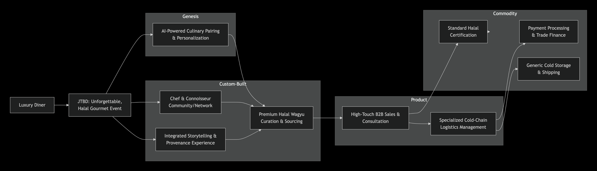

Key Insights from the Map:
- Strategic Dependencies: The entire experience relies on a few Custom-Built components: Wagyu AE's exclusive curation and the trusted community. These are your current differentiators.
- Commoditized Foundation: Critical but non-differentiating tasks like basic logistics and certification are commodities. This is where costs should be optimized.
- Future Genesis: AI-powered personalization represents a novel, future competitive edge that the market doesn't yet offer.

4. Applying the Six Platform Plays for Transformation
The transformation shifts the model from a linear pipeline (C-shape) to an interactive platform (Z-shape). Each "Play" targets a specific part of the value chain.
Platform Play (PP) | Application to Wagyu AE's Arena | Target Value Chain Component & Impact
PP1: Personalize Experience | Offer diners/chefs customized cut recommendations, pairing guides, and occasion-based menus. | Elevates AI-Powered Personalization (Genesis) to a core service.
PP2: Empower Producers | Provide chefs with direct tools (SaaS) for inventory management, cost tracking, and dynamic menu pricing for Wagyu dishes. | Products & bundles the High-Touch Sales (Product) process, making it scalable.
PP3: Standardize Transactions | Digitalize and automate ordering, contracts, and verification of halal/origin certifications. | Streamlines dependencies on Certification & Logistics (Commodity).
PP4: Embed Processes into SaaS | Bundle PP2's tools with integrated supply ordering, creating a "Kitchen Management Suite for Premium Proteins." | Creates a new, sticky Product out of fragmented Custom-Built knowledge.
PP5: Leverage Identity & Trust | Develop a verified reputation system for chefs and a transparent, blockchain-backed provenance tracker for each cut. | Institutionalizes the Community (Custom-Built) and Storytelling (Custom-Built) into a trust asset.
PP6: Aggregate Demand & Supply | Evolve from a sole distributor to a curated marketplace connecting other premium halal producers with high-end buyers. | This is the core platform shift, transforming Wagyu AE from the sole Aggregator to the Marketplace Orchestrator.
5. Risks, Evolution, and Strategic Roadmap
- Key Risks & Moats: The major risk is the exclusive Omi Beef partnership—a strong moat but a single point of failure. The future moat will be the network of chefs and suppliers and the data on preferences.
- Future Evolution: Components like provenance tracking will move from Custom-Built to a standardized Product (e.g., a blockchain utility). The marketplace itself will become the dominant, evolved form of the current aggregation model.
- Strategic Roadmap:
  - Phase 1 (Foundation): Digitize core assets. Implement PP3 & PP5 by launching Digital Product Passports for Omi Beef to enhance trust and streamline info.
  - Phase 2 (Enable): Launch a Chef's Guild community and a basic SaaS tool (PP4 & PP2) for your top clients. This tests value and starts building the network.
  - Phase 3 (Transform): Open a curated marketplace. Use your reputation to onboard other premium suppliers (PP6), leveraging the now-strong network and data.
This map clarifies that your immediate advantage is in Custom-Built curation, but your long-term, defensible position lies in building the platform ecosystem around it. The transformation into a multi-sided marketplace, powered by embedded SaaS tools and strong network effects, represents the most significant strategic evolution

Wardley Map Analysis - Premium Halal Culinary Experience"
1. Define the Context and Scope
- Arena: Premium Halal Culinary Experience.
- Systemic Job-to-be-Done (JTBD): “Create and deliver an unforgettable, culturally compliant gourmet dining event.”
- Key Players:
  - Customers/Users: High-net-worth individuals, luxury diners (seeking status, exclusivity).
  - Producers: High-end chefs and restaurants (creating the final experience).
  - Aggregator (Current): Wagyu AE (providing the core ingredient, trust, and expertise).
  - Infrastructure Providers: Halal certification bodies, cold-chain logistics, financial services.
2. & 3. Wardley Map: Current Value Chain & Evolutionary Stages
The map below visualizes the key components in the current value chain and their evolutionary stage, from novel (Genesis) to widely available (Commodity)
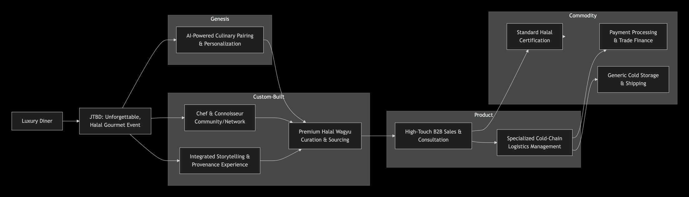

Key Insights from the Map:
- Strategic Dependencies: The entire experience relies on a few Custom-Built components: Wagyu AE's exclusive curation and the trusted community. These are your current differentiators.
- Commoditized Foundation: Critical but non-differentiating tasks like basic logistics and certification are commodities. This is where costs should be optimized.
- Future Genesis: AI-powered personalization represents a novel, future competitive edge that the market doesn't yet offer.

4. Applying the Six Platform Plays for Transformation
The transformation shifts the model from a linear pipeline (C-shape) to an interactive platform (Z-shape). Each "Play" targets a specific part of the value chain.
Platform Play (PP) | Application to Wagyu AE's Arena | Target Value Chain Component & Impact
PP1: Personalize Experience | Offer diners/chefs customized cut recommendations, pairing guides, and occasion-based menus. | Elevates AI-Powered Personalization (Genesis) to a core service.
PP2: Empower Producers | Provide chefs with direct tools (SaaS) for inventory management, cost tracking, and dynamic menu pricing for Wagyu dishes. | Products & bundles the High-Touch Sales (Product) process, making it scalable.
PP3: Standardize Transactions | Digitalize and automate ordering, contracts, and verification of halal/origin certifications. | Streamlines dependencies on Certification & Logistics (Commodity).
PP4: Embed Processes into SaaS | Bundle PP2's tools with integrated supply ordering, creating a "Kitchen Management Suite for Premium Proteins." | Creates a new, sticky Product out of fragmented Custom-Built knowledge.
PP5: Leverage Identity & Trust | Develop a verified reputation system for chefs and a transparent, blockchain-backed provenance tracker for each cut. | Institutionalizes the Community (Custom-Built) and Storytelling (Custom-Built) into a trust asset.
PP6: Aggregate Demand & Supply | Evolve from a sole distributor to a curated marketplace connecting other premium halal producers with high-end buyers. | This is the core platform shift, transforming Wagyu AE from the sole Aggregator to the Marketplace Orchestrator.
5. Risks, Evolution, and Strategic Roadmap
- Key Risks & Moats: The major risk is the exclusive Omi Beef partnership—a strong moat but a single point of failure. The future moat will be the network of chefs and suppliers and the data on preferences.
- Future Evolution: Components like provenance tracking will move from Custom-Built to a standardized Product (e.g., a blockchain utility). The marketplace itself will become the dominant, evolved form of the current aggregation model.
- Strategic Roadmap:
  - Phase 1 (Foundation): Digitize core assets. Implement PP3 & PP5 by launching Digital Product Passports for Omi Beef to enhance trust and streamline info.
  - Phase 2 (Enable): Launch a Chef's Guild community and a basic SaaS tool (PP4 & PP2) for your top clients. This tests value and starts building the network.
  - Phase 3 (Transform): Open a curated marketplace. Use your reputation to onboard other premium suppliers (PP6), leveraging the now-strong network and data.
This map clarifies that your immediate advantage is in Custom-Built curation, but your long-term, defensible position lies in building the platform ecosystem around it. The transformation into a multi-sided marketplace, powered by embedded SaaS tools and strong network effects, represents the most significant strategic evolution

Wardley Map Analysis - Connoisseur Identity & Access
1. Context and Scope: The Connoisseur Arena
- Ecosystem/Arena: Connoisseur Identity & Access within the premium food ecosystem.
- Systemic Job-to-be-Done (JTBD): “Access and possess rare, prestigious products that signify status and refined taste.”
  - For the Connoisseur: To discover, authenticate, and acquire exclusive items that serve as social capital.
  - For Wagyu AE: To cultivate a high-margin community of brand evangelists and capture direct consumer relationships.
- Key Players:
  - Customers: Ultra-High-Net-Worth Individuals (UHNWIs), collectors, elite gourmands.
  - Producers: Exclusive sources like Omi Beef and other ultra-premium, niche suppliers.
  - Aggregator/Curator: Wagyu AE, acting as the trusted gatekeeper and experience orchestrator.
  - Infrastructure: Luxury logistics, digital verification services, payment gateways for high-value transactions.
2. & 3. Wardley Map: Current Value Chain & Dependencies
The current state is a linear, high-touch, and opaque model. The map below illustrates the key components and their dependencies, arranged from the user's need (left) to the supporting infrastructure (right).
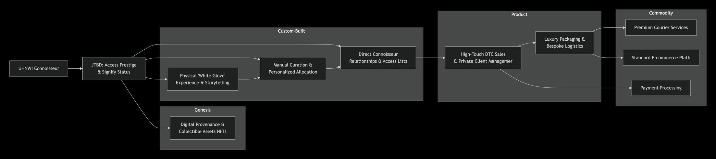

Key Insight: The entire system hinges on Custom-Built components—personal relationships and manual curation. This creates exclusivity but severely limits scale. The Genesis concept of digital collectible assets represents a potential future paradigm shift.
4. Evolutionary Stage of Components
- Genesis: Digital Provenance & Collectible Assets (NFTs). An emerging concept to transform a cut of meat into a verifiable, ownable digital asset that carries its story and history.
- Custom-Built: Direct Relationships, Manual Curation, Physical Experience. These are Wagyu AE's current differentiators—unique, labor-intensive, and not scalable.
- Product: High-Touch DTC Sales, Luxury Logistics. These are more standardized services but still tailored for the high-end market.
- Commodity: Courier Services, Payment Gateways, E-commerce Platforms. Ubiquitous utilities that offer no competitive advantage.
5. Strategic Plays for Platformization
Applying the Six Platform Plays transforms this linear chain into a multi-sided platform.
Platform Play | Application to Connoisseur Arena | Target Component & Strategic Impact
1. Personalize Experience | Curated product drops based on a connoisseur's taste profile and past acquisitions. | Evolves Manual Curation (Custom) into Algorithmic Personalization (Genesis/Product).
2. Empower Producers | Provide premium producers (e.g., Omi Beef) with a direct channel to showcase rare lots and tell their story to vetted end-users. | Creates a new Producer Platform (Product) layer, adding supply-side value.
3. Standardize Transactions | Digitalize the entire journey: from lot viewing and bidding to seamless payment and document transfer. | Commoditizes and streamlines the Transaction Layer, reducing friction.
4. Embed Processes into SaaS | Offer a "Cellar Management" digital vault for connoisseurs to track their collection, provenance, and value. | Products the Physical Experience (Custom) into a scalable Digital Service (Product).
5. Leverage Identity & Trust | Implement a gated, verified member reputation system. Status is earned through participation, knowledge sharing, and network contribution. | Institutionalizes Direct Relationships (Custom) into a scalable Trust & Reputation System (Product).
6. Aggregate Demand & Supply | Launch a members-only marketplace for rare proteins. Wagyu AE curates supply and vets demand, taking a transaction fee. | This is the core play. It transforms the entire model from a linear sales channel into a scalable network marketplace.
6. Risks, Evolution, and Strategic Roadmap
- Key Risks & Moats: The primary risk is over-reliance on manual curation, which limits growth. The current moat is the exclusive Omi partnership and private client list. The future moat must be the platform's community, data, and trust protocols.
- Future Evolution:
  - From Custom to Product: Curation and Community Management will become productized SaaS tools.
  - From Genesis to Mainstream: Digital Provenance will evolve from a novel concept to a standardized expectation, a key utility.
  - New Genesis: AI-driven taste matching and virtual reality farm experiences could emerge as new differentiation frontiers.
- Strategic Roadmap:
  - Phase 1: Digitize the Asset (0-6 Months): Launch Digital Product Passports for your most exclusive Omi Beef lots. This builds the essential trust infrastructure and tests the "collectible asset" concept with top clients.
  - Phase 2: Build the Gated Network (6-18 Months): Develop an invitation-only member portal. Start by migrating your existing UHNWI clients here. Introduce the first marketplace feature: periodic, exclusive "lot drops." Apply Platform Plays 3 & 5.
  - Phase 3: Scale the Ecosystem (18+ Months): Open the marketplace to a wider (but still vetted) audience. Onboard 2-3 other complementary ultra-premium producers (e.g., truffles, caviar). Introduce the "Cellar Management" SaaS tool (Play 4). Monetize through transaction fees and premium subscriptions.
This Wardley Map clarifies that your strength in Custom-Built relationships is the launchpad, but the strategic endpoint is a Product/Rental-based platform where scale, data, and network effects become the unassailable moat. The transformation involves systematically productizing your unique curation and trust into scalable digital services.

Wardley Map Analysis - Luxury Protein Supply
1. Context and Scope
- Ecosystem/Arena: Luxury Protein Supply—the operational backbone of sourcing and delivering ultra-premium, certified ingredients to high-end B2B clients.
- Systemic Job-to-be-Done (JTBD): “Source and deliver the highest-quality, certified raw ingredient reliably and efficiently.” This job is defined by guaranteed integrity (halal, breed purity), consistency (grade, cut), and perfect condition upon delivery.
- Key Players:
  - Customers: High-end restaurants, hotels, and caterers who require guaranteed quality and reliability.
  - Producers: Exclusive sources like Omi Beef and other premium Wagyu farms.
  - Aggregator/Service Provider: Wagyu AE, acting as the importer, logistics manager, and primary sales channel.
  - Infrastructure: Halal certification bodies (e.g., Japanese Islamic Trust), specialized cold-chain logistics, customs brokers.
2. & 3. Value Chain Components & Dependencies
The current state is a linear, push-based supply chain with significant manual coordination. The following table breaks down the key components and their dependencies.
Component Category | Key Components in Wagyu AE's Value Chain | Visibility & Dependencies
User Need & Value Proposition | Reliable Supply of A5 Halal Wagyu | Visible to client. Depends on all downstream components.
Products & Services | Curated Wagyu Cuts (Ribeye, Striploin, Tenderloin); Chef Training & Consultancy; VIP/White Label Programs | Visible/Marketed. Depend on sourcing and inventory.
Processes & Activities | High-Touch B2B Sales & Procurement; Inventory & Carcass Breakdown Planning; Order Fulfillment & Coordination | Invisible/Internal. Critical manual processes. Depend on logistics and inventory systems.
Technological Infrastructure | Basic Inventory Management; Member Portal for Live Pricing & Ordering; Email/Phone Communication | Invisible/Supporting. Rudimentary digital touchpoints. Depend on broader logistics tech.
Key Dependencies | Exclusive Producer Contracts (Omi Beef); Halal Certification & Traceability Docs; Specialized Cold-Chain Logistics; Customs & Trade Finance | Invisible/Core. The foundational pillars of the business.
Critical Bottleneck: The entire operation hinges on manual sales and planning processes to match a fixed, bulk inventory (whole carcasses) to variable client demand for specific cuts. This leads to inefficiency in carcass utilization and reactive, rather than predictive, operations.
4. Evolutionary Stage of Components
Positioning these components on the Wardley Evolution Curve reveals strategic opportunities.
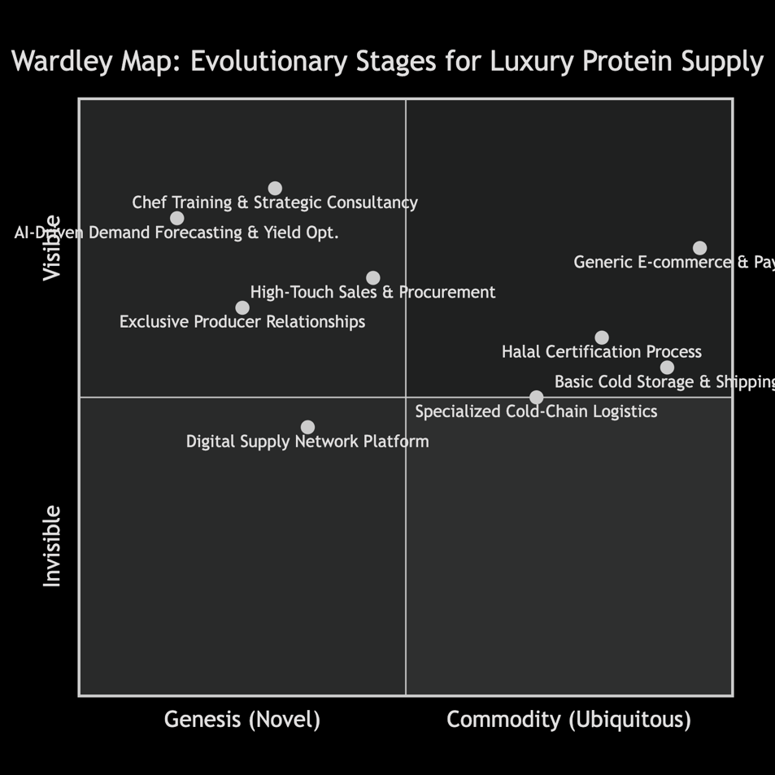

Analysis:
- Genesis/Custom-Built (Differentiation): Your exclusive relationships and high-touch services (like chef training) are core differentiators but are not scalable. AI-driven forecasting represents a future genesis opportunity to revolutionize planning.
- Product (Efficiency & Control): A Digital Supply Network Platform is the crucial missing product. It would digitize and streamline the core manual processes.
- Commodity (Cost Optimization): Basic logistics, payments, and generic e-commerce are utilities. The goal is to manage them at the lowest cost and highest reliability.

5. Strategic Plays for Platformization
Applying the Six Platform Plays transforms this linear chain into an efficient, multi-sided network.
Platform Play | Application to Luxury Protein Supply Arena | Target Component & Strategic Impact
1. Personalize Experience | Provide chefs with a portal showing curated cuts based on their menu style and past orders, with automated reordering triggers. | Enhances the Member Portal, moving it from a basic utility to a smart, value-adding service.
2. Empower Independent Producers | Offer a platform module for trusted producers (starting with Omi Beef) to showcase lot availability directly to your vetted buyer network. | Strengthens and scales Exclusive Relationships into a digital producer enablement service.
3. Standardize Transactions | Digitize the entire order-to-certificate flow: online ordering, automated documentation, and integrated logistics tracking. | Eliminates friction in Order Fulfillment, reducing cost and error.
4. Embed Processes into SaaS | Bundle inventory management, demand forecasting, and cut optimization into a "Supply Orchestrator" tool for your operations team. | Products the manual planning process, creating a scalable operational core.
5. Leverage Identity & Trust | Integrate immutable digital certificates and provenance tracking (e.g., blockchain) directly into each product listing. | Hardens Halal Certification into a digital trust utility, a powerful market moat.
6. Aggregate Demand & Supply | Evolve into a digital sourcing hub. Aggregate demand from multiple chefs to optimize carcass breakdowns and offer rare cuts from multiple premium suppliers. | This is the core transformation, turning Wagyu AE from a linear distributor into a network orchestrator.
6. Risks, Evolution, and Strategic Roadmap
- Key Risks & Moats: The primary risk is operational rigidity—high inventory costs and inefficient matching. The current moat is the exclusive Omi Beef contract. The future moat must be the platform's efficiency, data intelligence, and network of buyers/suppliers.
- Future Evolution:
  - From Custom to Product: High-touch sales and planning will be productized into the Supply Orchestrator SaaS and Digital Network Platform.
  - From Genesis to Mainstream: AI-driven forecasting will evolve from an experiment to the standard operating system for inventory and procurement.
  - Commoditization Pressure: Basic logistics coordination will become a fully automated utility within the platform.
- Strategic Roadmap:
  - Phase 1: Digitize the Core (0-6 Months): Build the Digital Product Passport and enhance the Member Portal into a true transactional platform for your top 20% of clients. Apply Plays 3 and 5.
  - Phase 2: Productize Operations (6-18 Months): Develop the internal "Supply Orchestrator" SaaS tool (Play 4). Use it to manage inventory and test demand aggregation models with a small group of chefs and one additional supplier (Play 6).
  - Phase 3: Scale the Network (18+ Months): Officially launch the multi-supplier Luxury Protein Platform. Open it to a wider circle of vetted buyers and niche producers. Monetize through transaction fees and premium SaaS subscriptions.
This analysis clarifies that your current advantage in Custom-Built sourcing is vital but operationally limiting. The strategic future lies in building a Product-stage platform that systematizes this excellence, creating a defensible position through operational supremacy and network scale.

Wardley Map Analysis - Wagyu AE's Ecosystem
1. Define the Context and Scope
- Ecosystem: The Global Premium Halal Wagyu Beef Ecosystem within the UAE and wider GCC luxury food market.
- Systemic Job-to-be-Done (JTBD): “Access authentic, luxurious, and culturally compliant Wagyu beef to deliver exceptional dining experiences and signify status.”
  - For B2B Chefs: Source the highest-quality, certified ingredient to create a prestigious menu centerpiece.
  - For B2C Connoisseurs: Acquire a rare, status-signifying product with a guaranteed story of origin and quality.
- Key Players:
  - Users: Luxury diners (end JTBD), High-end chefs & UHNWI households (direct customers).
  - Producers: Omi Beef (exclusive), other Wagyu farms (potential).
  - Aggregators: Wagyu AE (current core), potential platform ecosystem partners.
  - Infrastructure: Halal certifiers, cold-chain logistics, genetic/breeding platforms, trade finance.
2. Identify Components in the Value Chain
This table lists the essential components for delivering value, categorized for the Wardley Map.
Component Category | Key Components for Wagyu AE
User Need & Value Proposition | Premium Halal Wagyu Dining Experience (for end-user), Reliable Supply of A5 Halal Wagyu (for chef), Access to Exclusive, Rare Cuts (for connoisseur).
Visible / User-Facing | Personalized Curation & Storytelling, Chef Consultancy & Training, "White Glove" Concierge Service, Member Portal/Access.
Invisible / Supporting Processes | High-Touch B2B Sales & Procurement, Halal Certification & Compliance Management, Inventory & Carcass Yield Optimization, Order Fulfillment & Logistics Coordination.
Technological Infrastructure | Basic CRM & Inventory Systems, Communication Tools (Email/Phone), Potential: Digital Traceability Layer, Data Analytics for Demand Forecasting.
Critical Dependencies | Exclusive Omi Beef Supply Contract, Specialized Cold-Chain Logistics, Halal Certification Authorities, Global Wagyu Genetics & Breeding Data, Cross-Border Trade Regulations.
3. Position Components and Assess Evolutionary Stage
The core of a Wardley Map is plotting each component based on its maturity and dependency relationships, moving from the user need (left) to commodity infrastructure (right).

Evolutionary Stages Explained:
- Genesis: Novel, uncertain, and constantly changing (e.g., experimental technology).
- Custom-Built: Unique, tailored solutions built in-house for specific needs.
- Product (+Rental): Standardized, commercially available offerings you can rent or buy.
- Commodity (+Utility): Ubiquitous, standardized, utility-like services.
The following analysis applies these stages to Wagyu AE's value chain, with strategic notes for platformization.
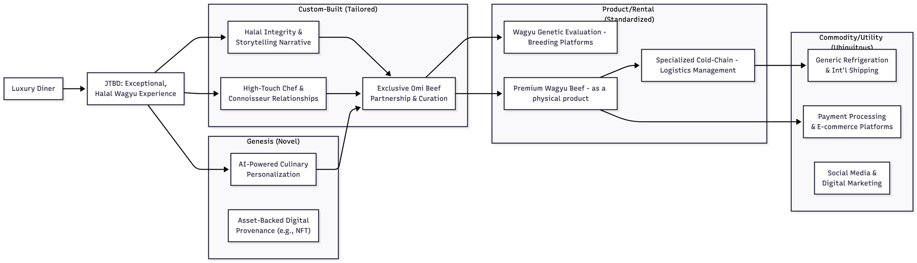

4. Strategic Plays for Platformization
Applying the Six Platform Plays to the mapped components reveals targeted transformation strategies.
Platform Play | Application to Wagyu AE's Value Chain | Strategic Impact & Target Component
1. Personalize Experience | Use data from chef orders and connoisseur preferences to offer AI-curated cuts, pairing suggestions, and occasion-based menus. | Transforms Customer Relationships (Custom) into a scalable data-driven service, enhancing AI-Powered Personalization (Genesis).
2. Empower Producers | Provide Omi Beef and other premium producers with a direct digital channel to showcase rare lots, tell their story, and access market data. | Products and scales the Exclusive Partnership (Custom), creating a producer enablement layer.
3. Standardize Transactions | Digitize ordering, contracts, certification transfer, and payments into a seamless workflow for B2B and B2C clients. | Streamlines and commoditizes the Transaction Layer, reducing friction in Order Fulfillment.
4. Embed Processes into SaaS | Bundle yield optimization, inventory forecasting, and procurement into a "Supply Orchestrator" SaaS tool for your team and clients. | Products internal Processes (Custom) into a commercial product, increasing efficiency and stickiness.
5. Leverage Identity & Trust | Implement a blockchain-verified digital passport for each cut, immutable proof of halal status, Omi lineage, and journey. | Hardens Halal Integrity (Custom) into a digital trust utility, a powerful market moat and new Digital Provenance (Genesis) asset.
6. Aggregate Demand & Supply | Evolve into a curated marketplace. Aggregate demand from chefs to optimize carcass yields and connect niche producers with verified buyers. | The core shift from a linear distributor (owning all supply) to a network orchestrator (facilitating connections).

5. Risks, Future Evolution & Strategic Roadmap
- Key Risks & Strategic Moats:
  - Primary Risk: Over-reliance on the single Custom-Built asset: the Omi Beef contract. It's a strong moat but a single point of failure.
  - Future Moat: The platform's network effects (chefs + producers + data) and digital trust assets (provenance system) will become the sustained competitive advantages.
- Future Evolution of the Map:
  - From Custom to Product: High-touch relationships and manual processes will be productized into the platform's community and SaaS tools.
  - From Genesis to Mainstream: AI Personalization and Digital Provenance will evolve from novel experiments to expected, standardized features.
  - Commoditization Pressure: Basic logistics coordination will become a fully automated, low-cost utility within the platform ecosystem.
- Strategic Roadmap:
  - Phase 1: Digitize the Core (0-6 Months): Launch Digital Product Passports for Omi Beef. Enhance your member portal with live inventory and online ordering. (Applies Plays 3 & 5).
  - Phase 2: Build the Network (6-18 Months): Formally launch an invitation-only "Chef's Guild" community. Introduce a basic SaaS dashboard for inventory planning. Onboard 1-2 complementary premium producers as a test. (Applies Plays 1, 4 & begins 6).
  - Phase 3: Scale the Platform (18+ Months): Officially open the curated Wagyu marketplace to a wider, vetted network. Monetize through transaction fees, premium subscriptions, and data insights. Continuously evolve the Genesis-stage components.
This analysis provides the strategic landscape for Wagyu AE's transformation. To begin executing, the most critical next step is to validate the biggest assumption: Will high-end chefs and UHNWIs value and pay for a digital provenance story?

Brief Consolidation - Wagyu AE's Ecosystem
1. Define the Ecosystem and Context
- Ecosystem Name: The UAE Premium Halal Wagyu Ecosystem.
- Scope & Description: This ecosystem comprises the global network of entities required to source, certify, distribute, and serve the highest grade of halal Wagyu beef to the luxury market in the United Arab Emirates. It is characterized by extreme demands for quality (authentic genetics, superior marbling), trust (verified halal certification, undisputed provenance), and exclusivity.
- Major Entities & Core Value Exchange:
  - Producers (e.g., Omi Beef): Supply authentic product + brand prestige + genetic story.
  - Distributor/Aggregator (Wagyu AE): Supplies curated access + guaranteed integrity + market expertise.
  - Consumers - B2B (High-end chefs): Seek reliable, supreme-quality ingredient + operational certainty to create prestige.
  - Consumers - B2C (UHNWIs): Seek status-signifying possession + unique experience + social capital.
- Primary Systemic Job: “Access authentic, luxurious, and culturally compliant Wagyu beef to deliver exceptional dining experiences and signify status.”
2. Explore "What If" Scenarios Using Platformization Patterns
Based on PDT patterns, here are three strategic scenarios for Wagyu AE's evolution.
Scenario & Core Pattern | How It Reshapes the Ecosystem | New Roles & Opportunities
1. The Curated Marketplace (Aggregation Pattern)  Pattern: Connecting fragmented supply and demand. | Wagyu AE evolves from a sole distributor to a multi-sided platform. It onboards other premium halal protein producers (e.g., specialty lamb, select seafood) alongside its anchor Omi Beef supply. | New Roles: Platform curator, trust arbitrator, data analyst.  Opportunities: Transaction fees, premium listing services, demand aggregation for better producer planning.  Innovation: Dynamic pricing for rare cuts, algorithmic matching of cuts to chef menu styles.
2. The Trust & Provenance Utility (Infrastructure Pattern)  Pattern: Productizing a core, complex capability into a scalable service. | Wagyu AE productizes its deep expertise in halal integrity and traceability into a white-label SaaS platform. Restaurants and other importers use this to provide digital provenance passports to their customers. | New Roles: Trust-as-a-Service provider, certification tech developer.  Opportunities: SaaS subscription revenue, becoming the regional standard for halal luxury verification.  Innovation: Blockchain-ledger for full lifecycle tracking, integrated halal audit logs.
3. The Connoisseur's Guild (Community & Identity Pattern)  Pattern: Leveraging shared identity and passion to build a high-trust network. | Wagyu AE builds a gated, digital community platform for UHNWIs and master chefs. Value shifts from pure product sales to membership, exclusivity, and co-created experiences. | New Roles: Community manager, experience curator, educator.  Opportunities: High-margin membership fees, exclusive event ticket sales, curated product drops.  Innovation: Member-voted product imports, virtual farm tours with Omi Beef masters, peer knowledge sharing.

3. Analyze the Long Tail Market Dynamics
The ecosystem exhibits strong long-tail dynamics, creating the ideal conditions for platformization.
- Fragmented Supply: Beyond major brands like Omi, there are many small, niche Wagyu farms (in Japan, Australia, the US) producing exceptional, specialized beef with unique genetics or feeding programs. They struggle to access the concentrated UAE luxury market.
- Specialized Demand: High-end chefs and UHNWIs are increasingly seeking hyper-personalization. A chef may want a specific ribeye grade for a tasting menu, while a connoisseur seeks a whole specific muscle cut for a private event. The one-size-fits-all distribution model is inefficient for these niche needs.
- Technology as an Enabler: Digital platforms, cold-chain tracking, and online verification dramatically lower the transaction costs of connecting these fragmented parties. A small Australian farmer can now feasibly sell directly to a Dubai hotel if a trusted platform handles logistics, trust, and payment.
4. Assess Aggregator Potential
The need for a sophisticated aggregator is clear and urgent.
- Inefficient Current State: Valuable supply (niche producers) and demand (specific chef needs) are disconnected. Transactions are mediated through manual, relationship-driven brokers or not happening at all. This creates high search costs, opacity, and inefficiency.
- Aggregator Opportunity: A digital aggregator (marketplace) could:
  - Organize Supply: Catalog and curate a wide array of premium products under a unified quality and trust standard.
  - Match Efficiently: Use data to connect specific cuts with chefs seeking them, optimizing yield and reducing waste.
  - Enhance Trust: Centralize and digitize verification (halal, provenance), becoming a trust layer for the entire ecosystem.
- Competitive Position: No dominant digital aggregator exists for premium halal meat specifically. Wagyu AE, with its exclusive Omi anchor and deep market credibility, is uniquely positioned to build this.
5. Identify Key Infrastructural Components
A successful platform requires building or leveraging specific infrastructural components.
- Existing Infrastructure to Leverage:
  - Physical: Specialized cold-chain logistics, halal certification bodies.
  - Digital: Payment gateways, cloud hosting, communication APIs.
- Missing/Critical Infrastructure to Build:
  - Digital Trust Layer: A system to issue and verify immutable digital product passports (combining origin, halal certs, handling data).
  - Matchmaking & Discovery Engine: Algorithms for personalized product recommendations and efficient carcass yield optimization across multiple buyers.
  - Community & Reputation System: Tools for managing a gated member community, with profiles, reviews, and contribution tracking.
6. Define Ecosystem Innovation Opportunities
Platformization enables recombining assets to create novel value.
- Recombining Assets for New Experiences:
  - Omi Beef + Chef Network + Digital Passport: Create a "Chef's Table Experience" where diners scan a QR code to see the story of their specific cut and the chef's preparation notes.
  - Producer Network + Logistics + DTC Platform: Enable "Crowd-butchering" where multiple UHNWIs can collectively purchase and split a whole, rare carcass, facilitated by the platform.
- Unlocking Underutilized Assets:
  - Chef Expertise: The platform can capture and monetize chefs' knowledge through premium tutorial content or consultancy services for other members.
  - Demand Data: Aggregated, anonymized purchasing data becomes a valuable asset that can guide producers' breeding and feeding programs.
7. Finalizing the Brief Consolidation
- Most Viable & Transformative Scenario: The Curated Marketplace scenario has the highest strategic leverage. It directly leverages your core asset (Omi Beef as a trust anchor) to solve the most significant ecosystem pain point (fragmented connection). It paves the way for the other scenarios—once the marketplace is established, the Trust Utility and Connoisseur's Guild become natural, high-margin extensions.
- Strategic Synthesis: Your path is to evolve from Asset Owner (of inventory) to Network Orchestrator. The exclusive Omi contract is the launchpad, not the end state. The ultimate goal is to own the digital infrastructure of trust and connection for the luxury halal protein market.
- Recommended Next Steps:
  - Validation Sprint: Test the core value hypothesis of the marketplace. Manually facilitate 3-5 transactions connecting a niche producer (not Omi) with a chef client. Document the friction and value created.
  - Build the First Infrastructure Block: Develop the Digital Product Passport MVP for your Omi Beef line. This is a concrete first step towards the trust layer and provides immediate marketing value.
  - Design the "Minimum Viable Ecosystem" (MVE): Sketch the simplest version of the marketplace that could work—likely a private, invitation-only site for your top 20 clients featuring Omi Beef plus one other producer.
This consolidation points towards a clear, staged platform strategy. To move from analysis to action, the most critical next step is to validate demand for the marketplace concept with your existing clients.

